**Day-2 Azure**

**Visualization:**

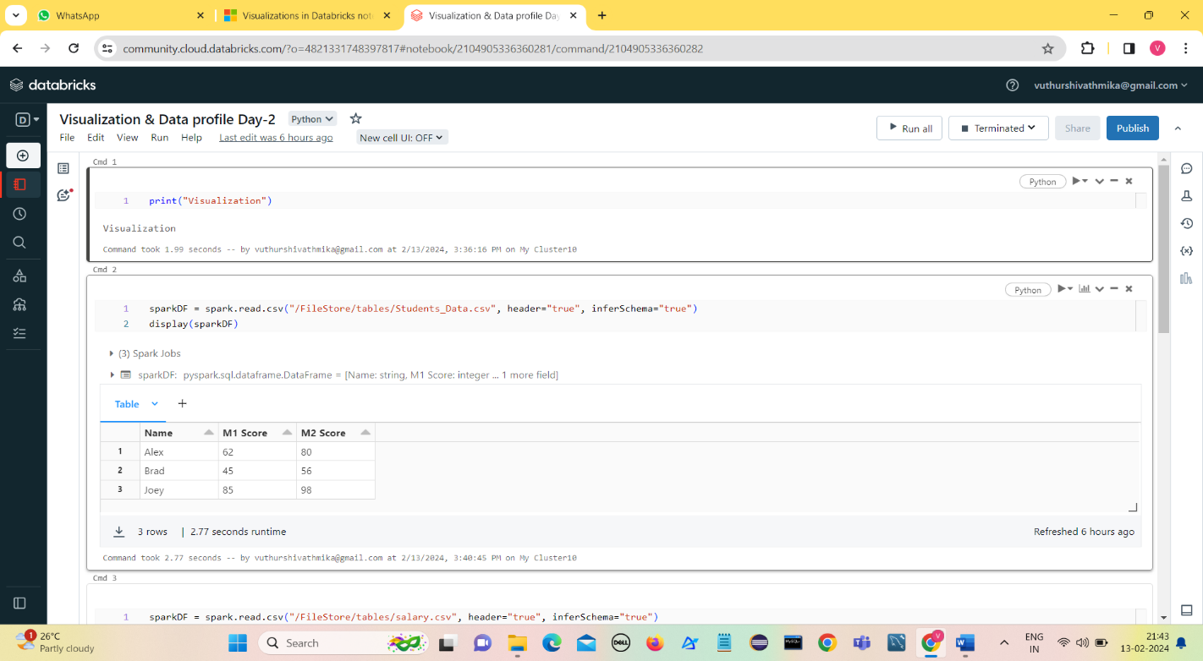Azure Databricks has built-in support for charts and visualizations in both Databricks SQL and in notebooks.

1. 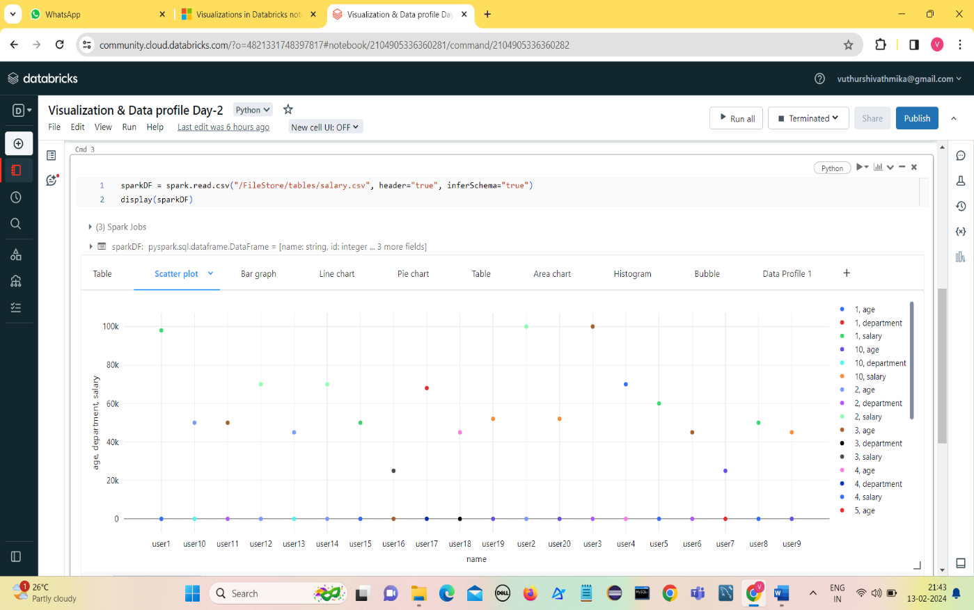**Scatter plot**
2. 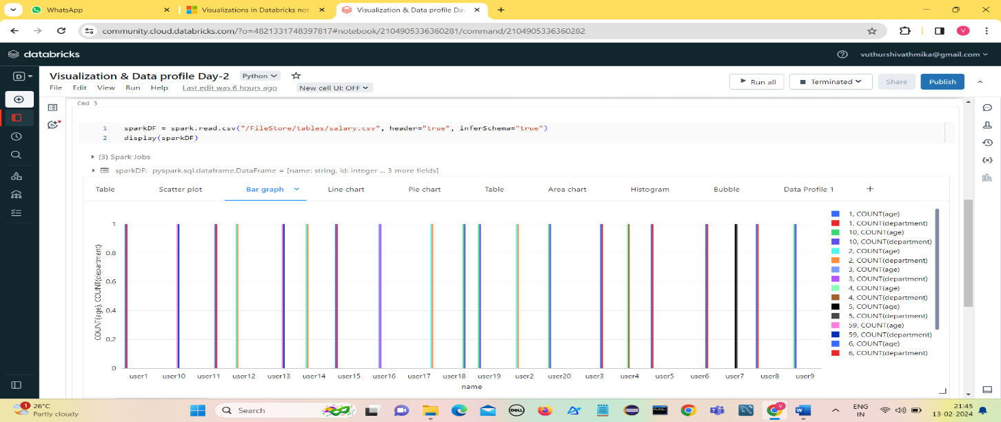**Bar graph**
3. 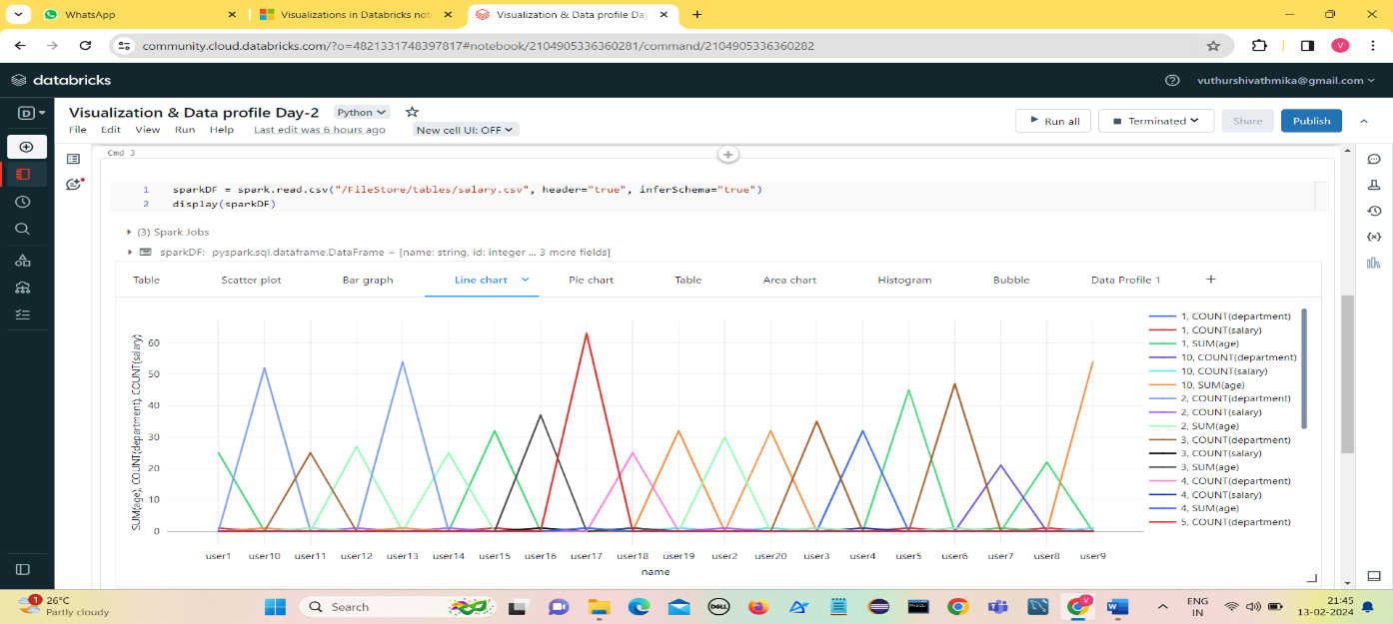**Line Chart**
4. 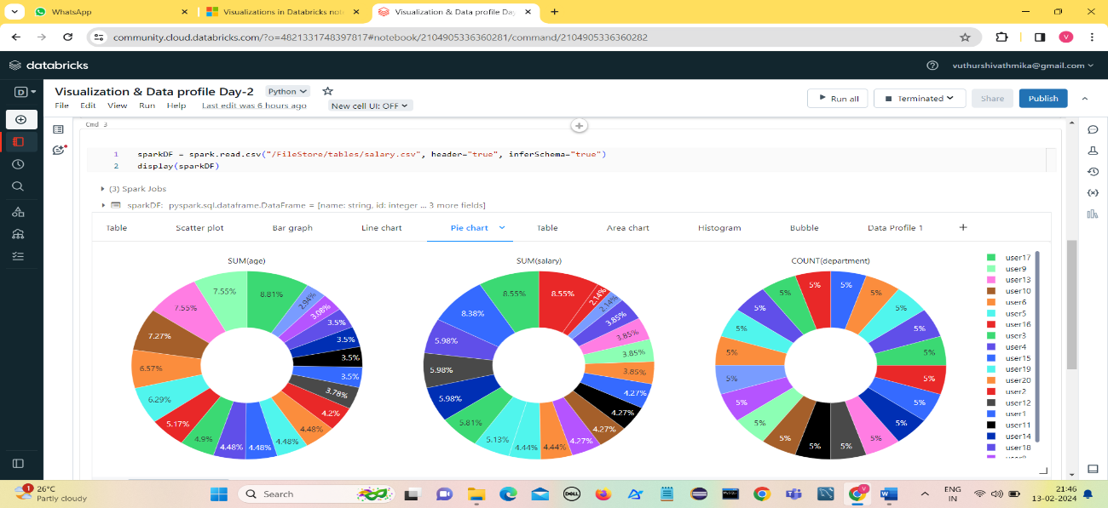**Pie chart**
5. 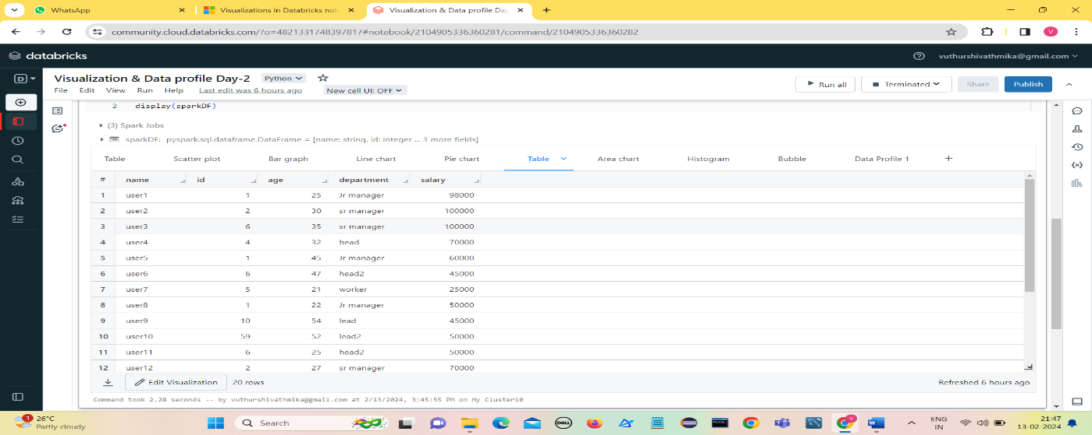**Table**
6. 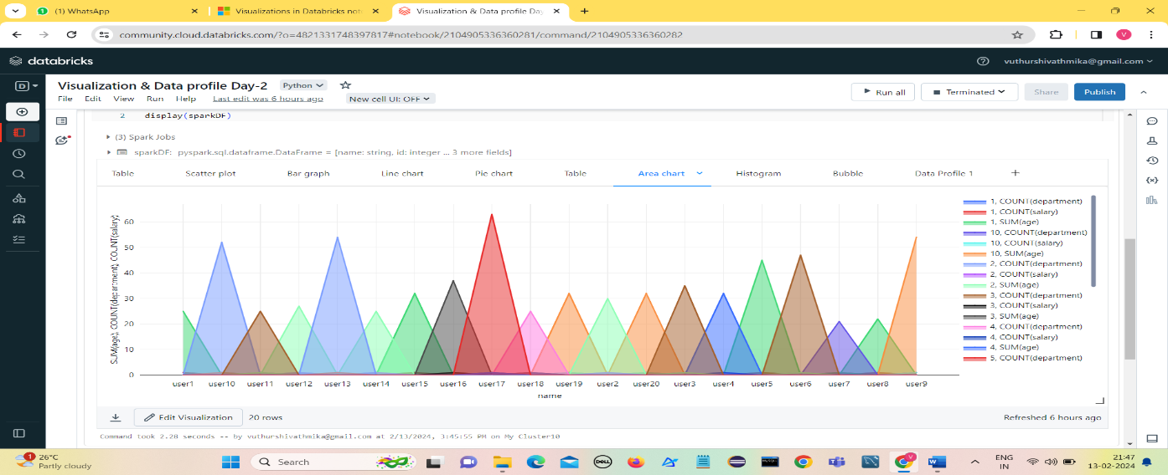**Area Chart**
7. 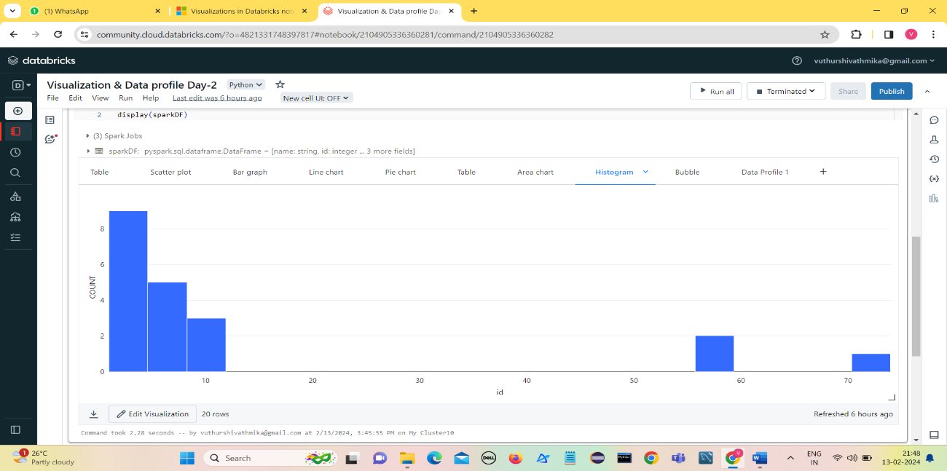**Histogram**
8. 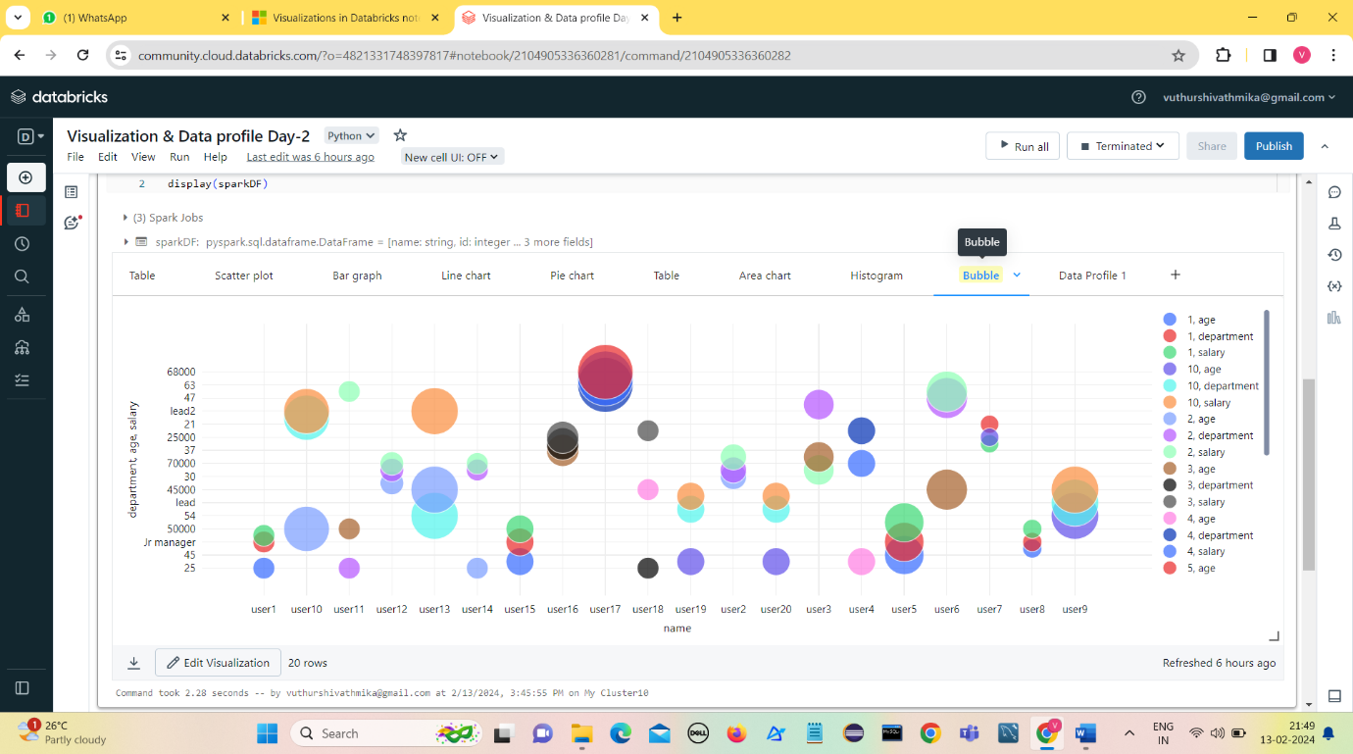**Bubble**

**Data Profile**

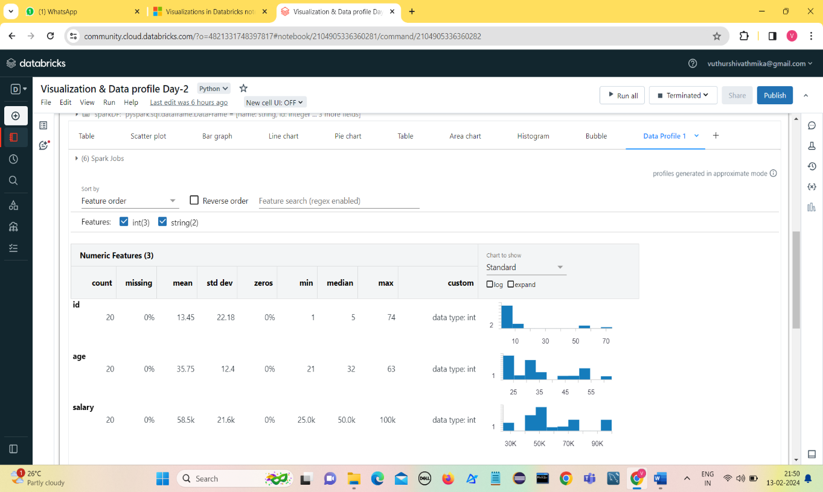Data profiles display summary statistics of an Apache Spark DataFrame, a pandas DataFrame, or a SQL table in tabular and graphic format.

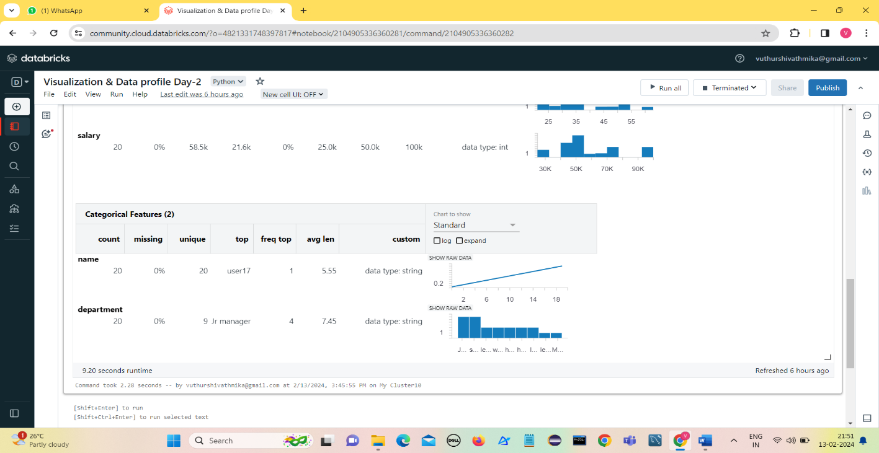

* Numeric and categorical features are shown in separate tables.
* At the top of the tab, you can sort or search for features.
* At the top of the chart column, you can choose to display a histogram (**Standard**) or quantiles.
* Check **expand** to enlarge the charts.
* Check **log** to display the charts on a log scale.
* You can hover your cursor over the charts for more detailed information, such as the boundaries of a histogram column and the number of rows in it, or the quantile value.

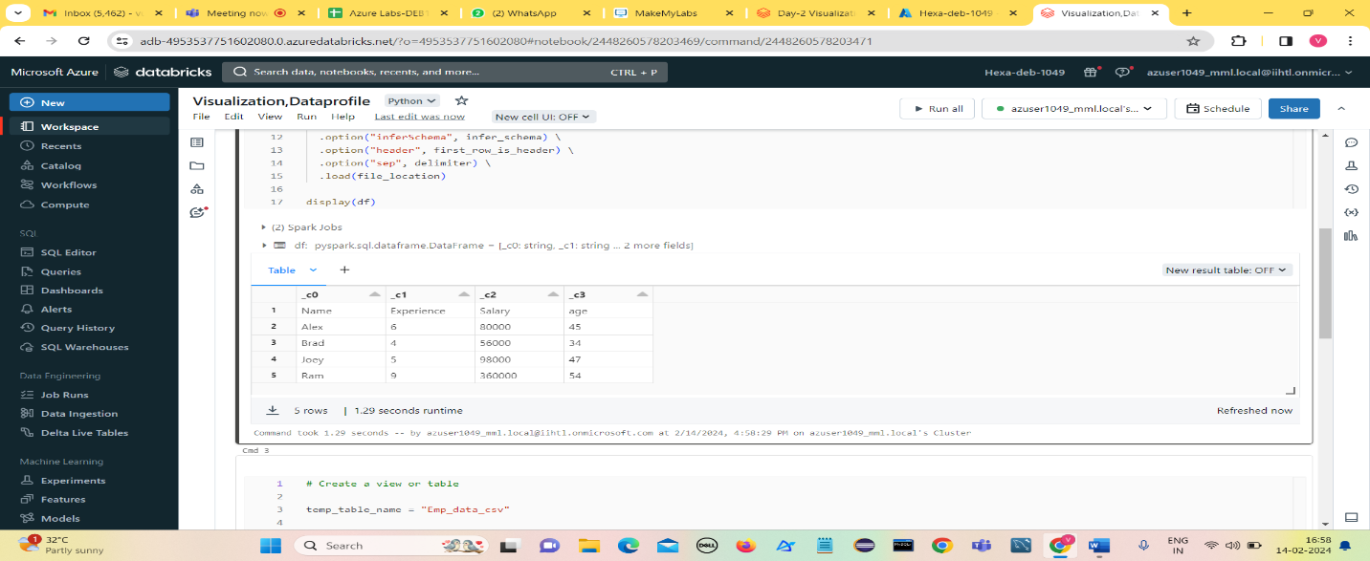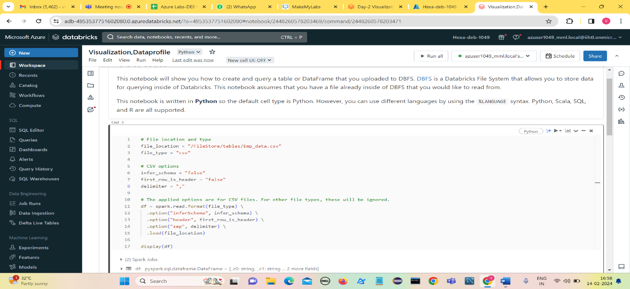**From Azure: create table with notebook**

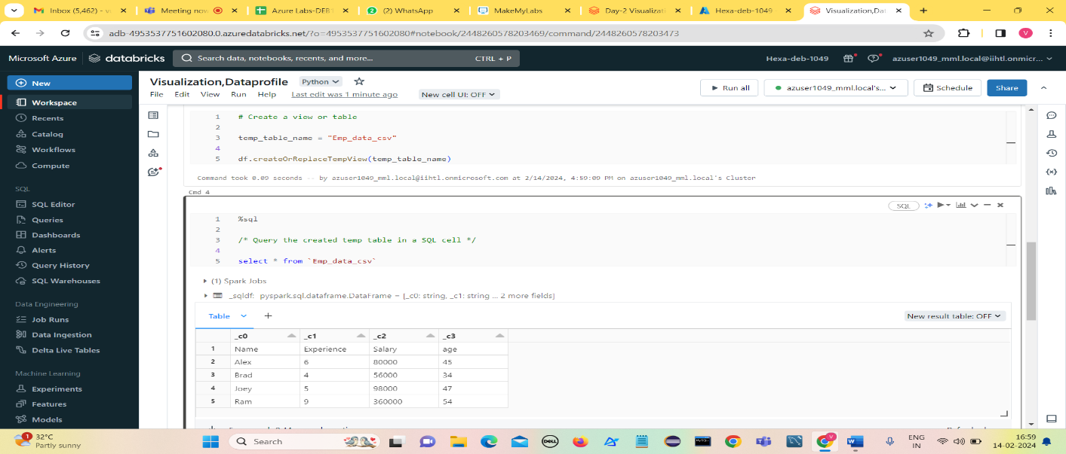

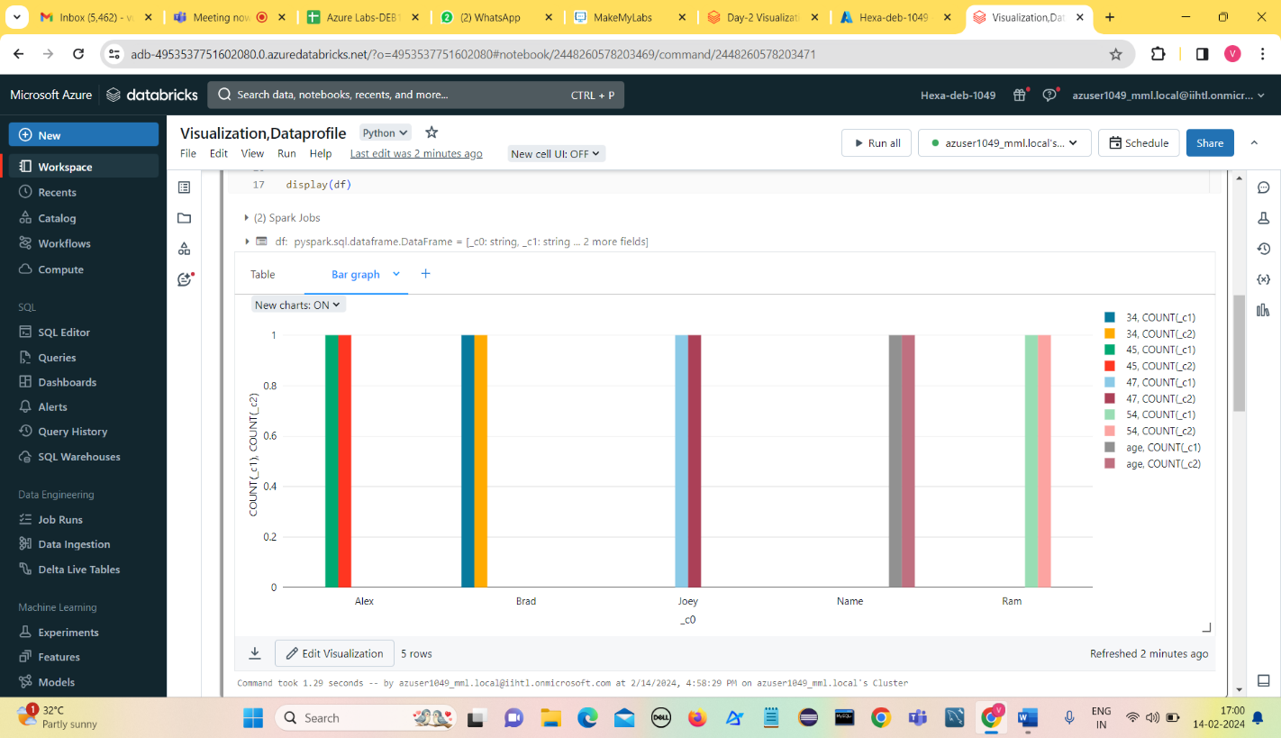

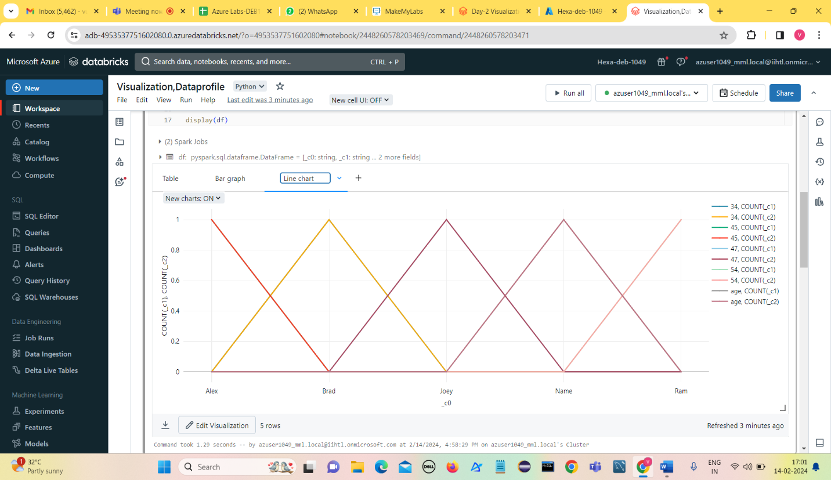

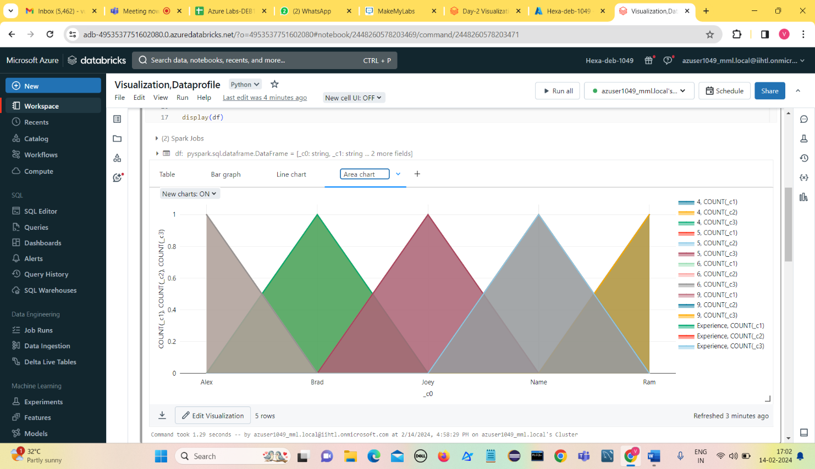

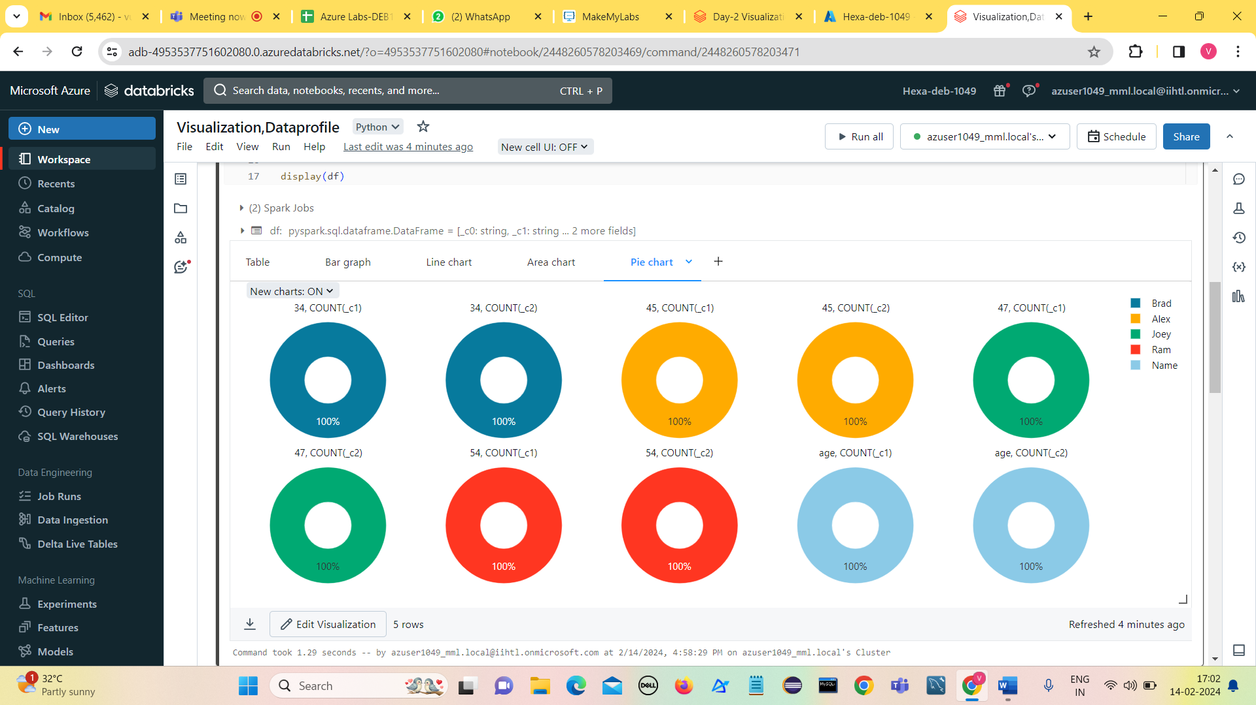

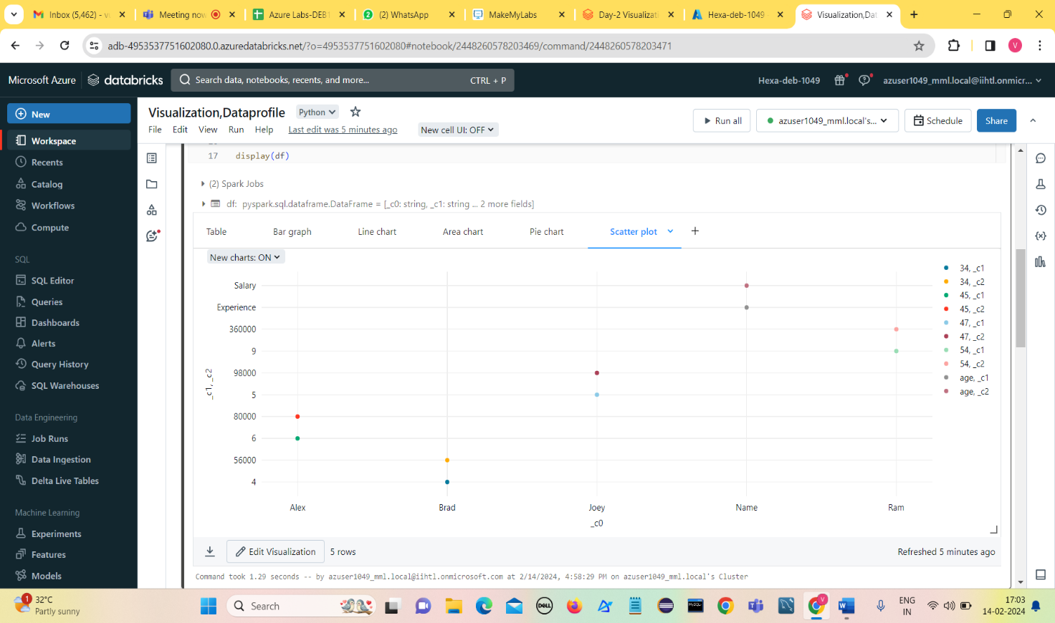

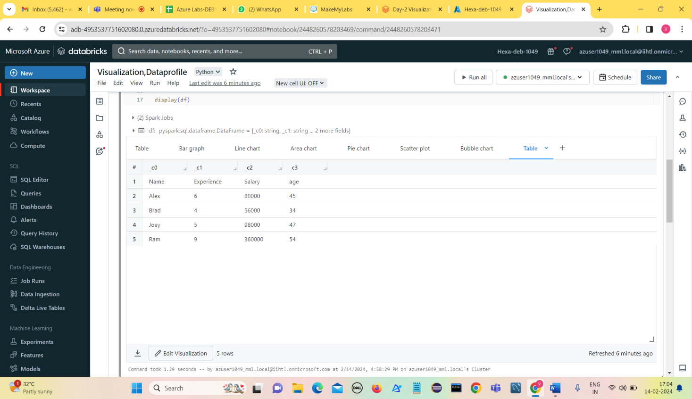

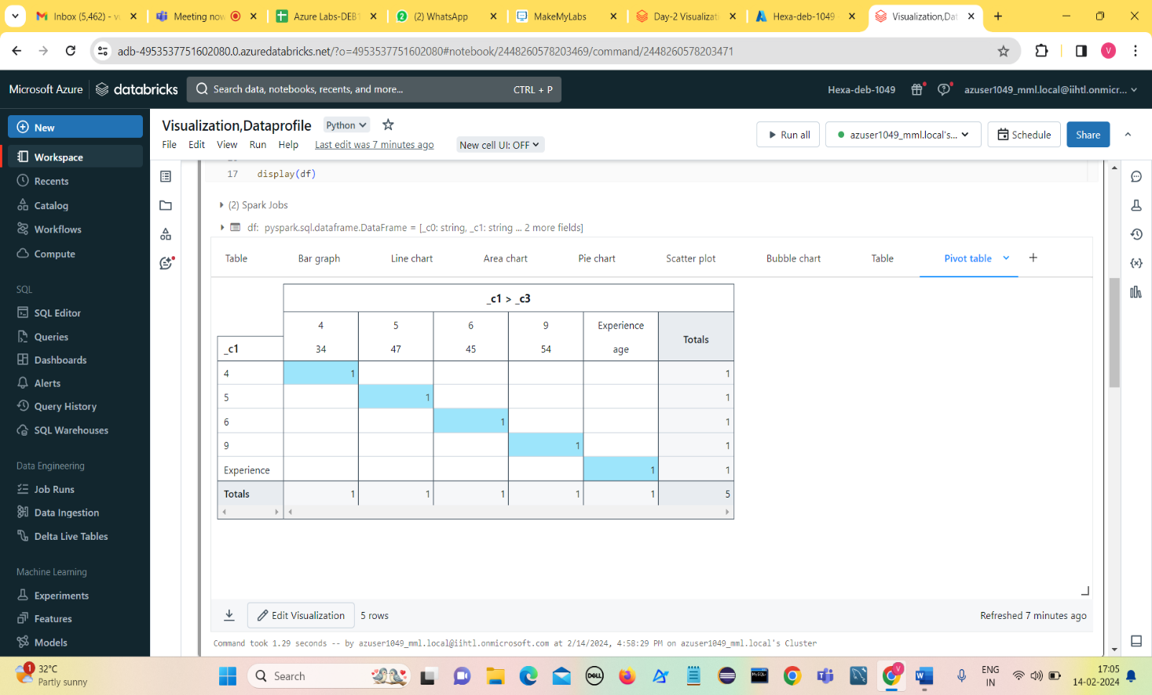

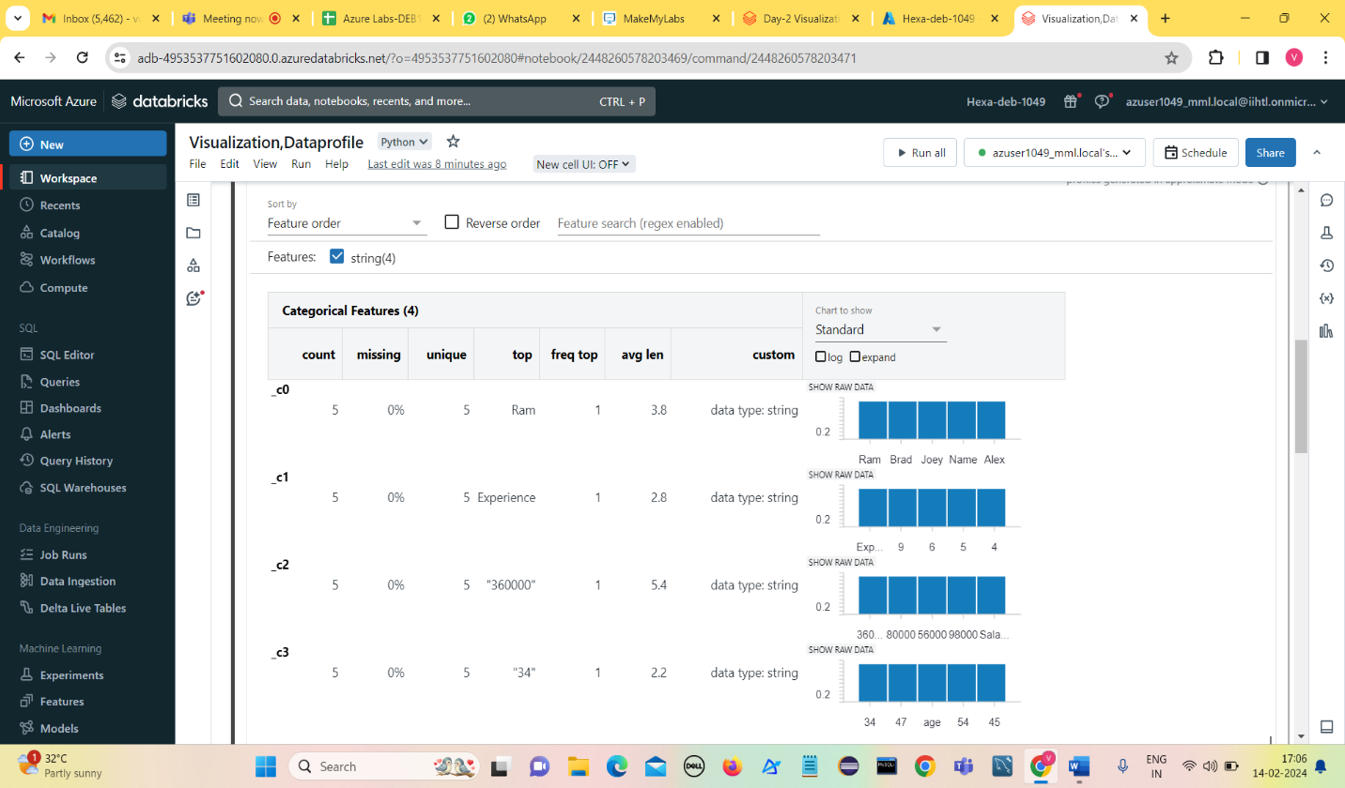**Data profile:**

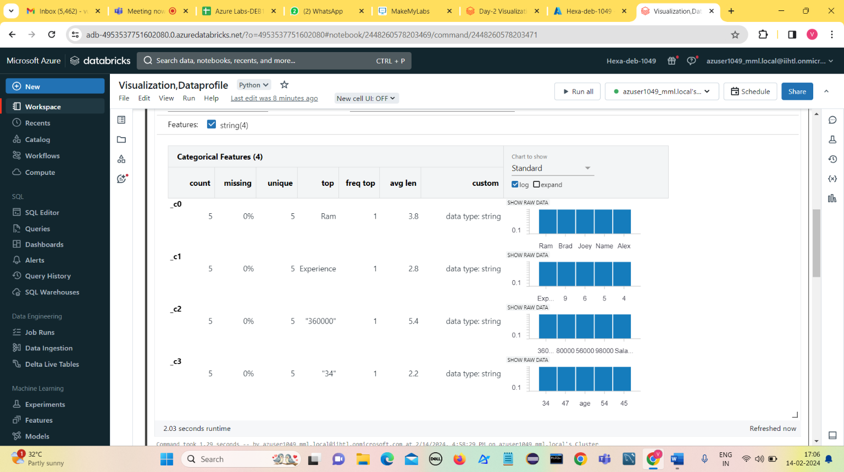**Using log**

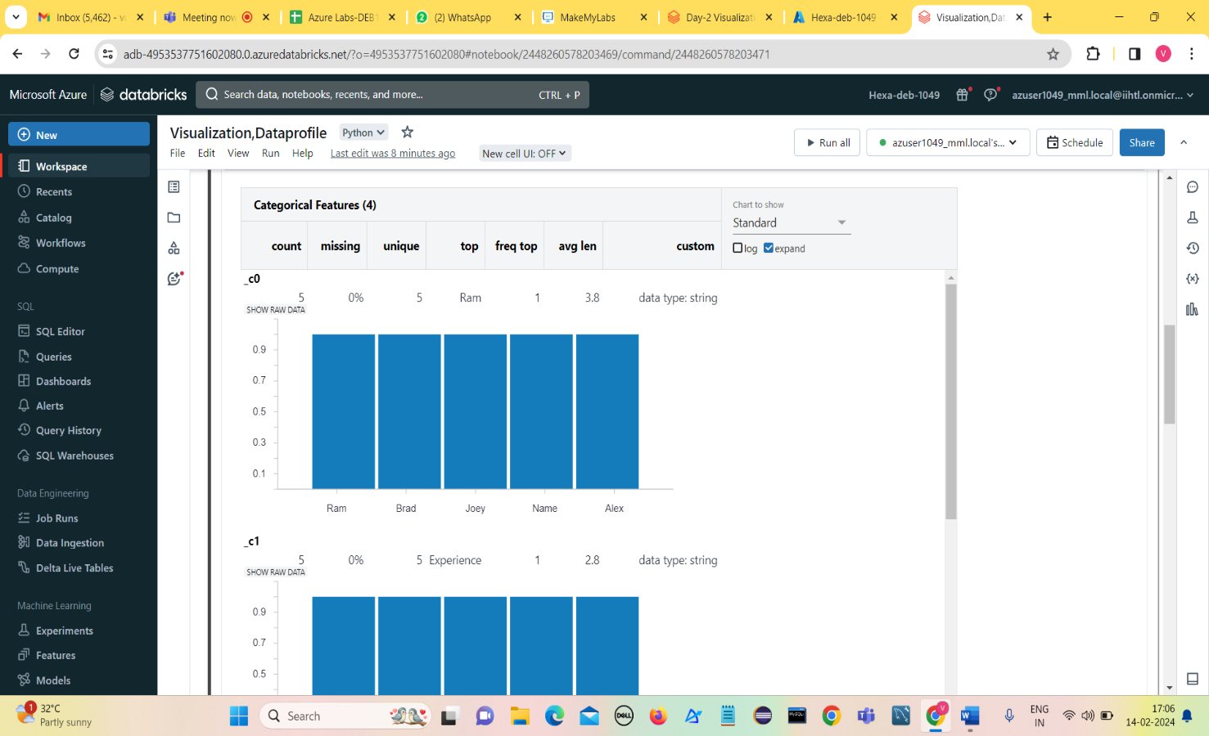**Using Expand**

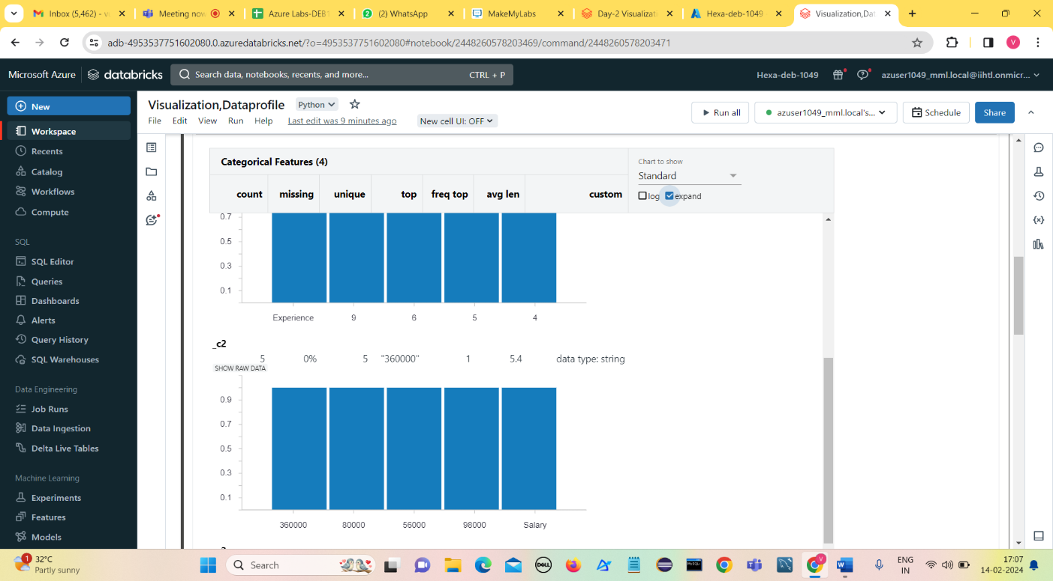

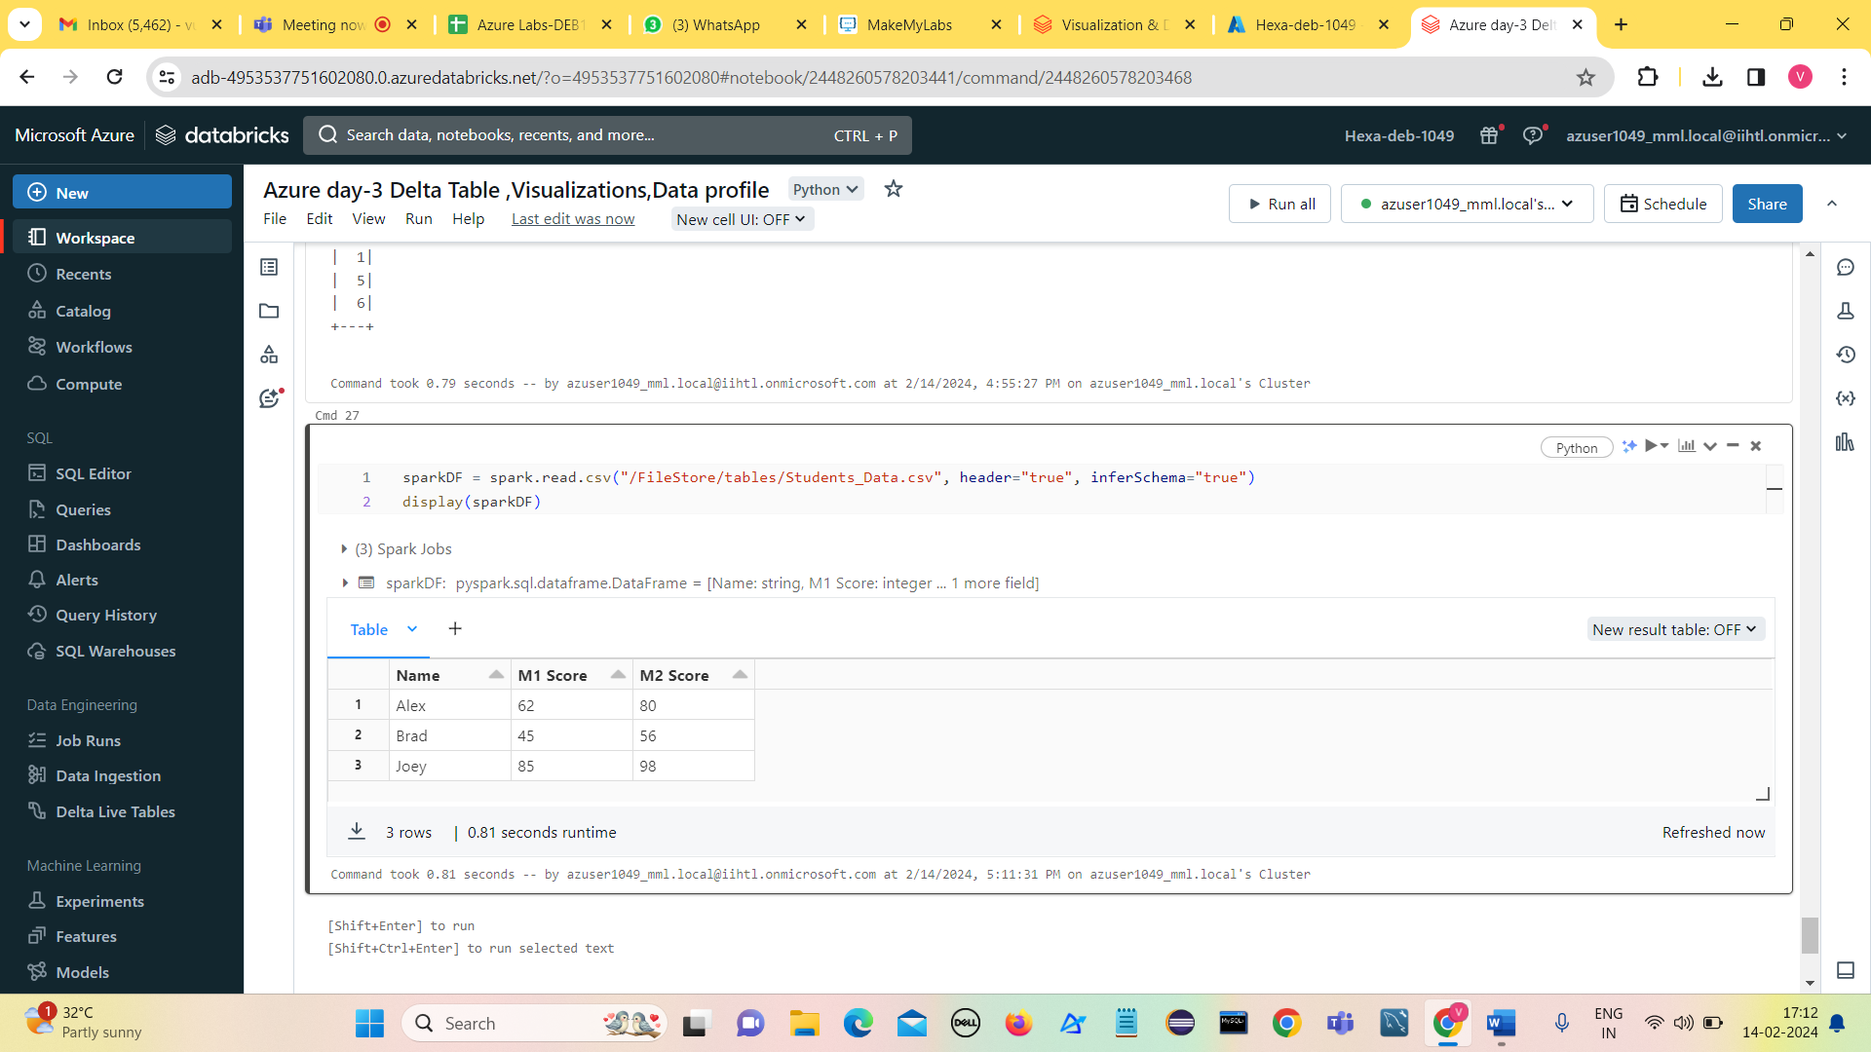**Importing file from local as DBFS and creating table in UI**

**Run a Databricks notebook from another notebook**

* The **%run** command allows to include another notebook within a notebook.
* We can use %run to modularize code, for example by putting supporting functions in a separate notebook.
* We can also use it to concatenate notebooks that implement the steps in an analysis.
* When we use %run, the called notebook is immediately executed and the functions and variables defined in it become available in the calling notebook.

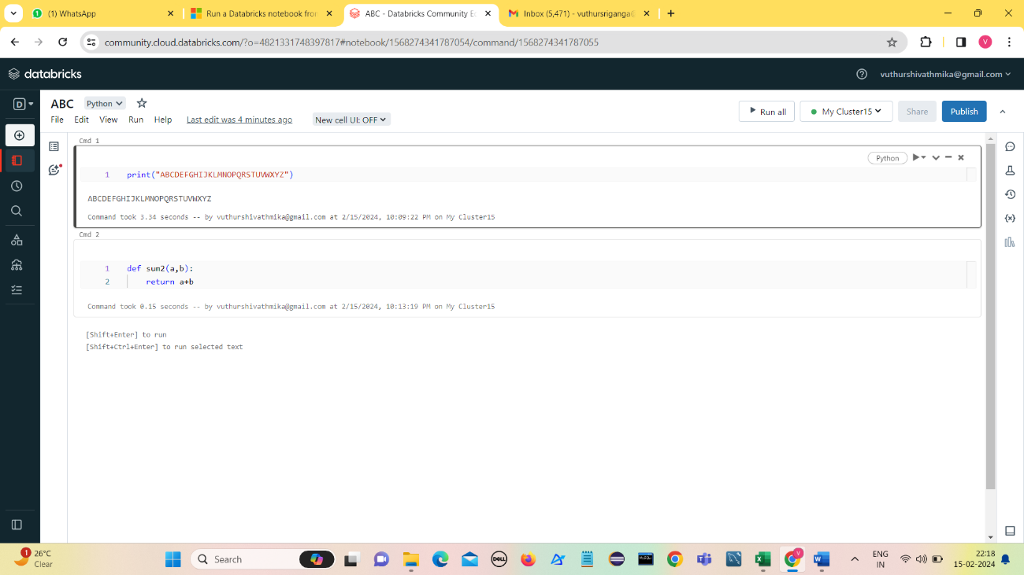**First notebook**

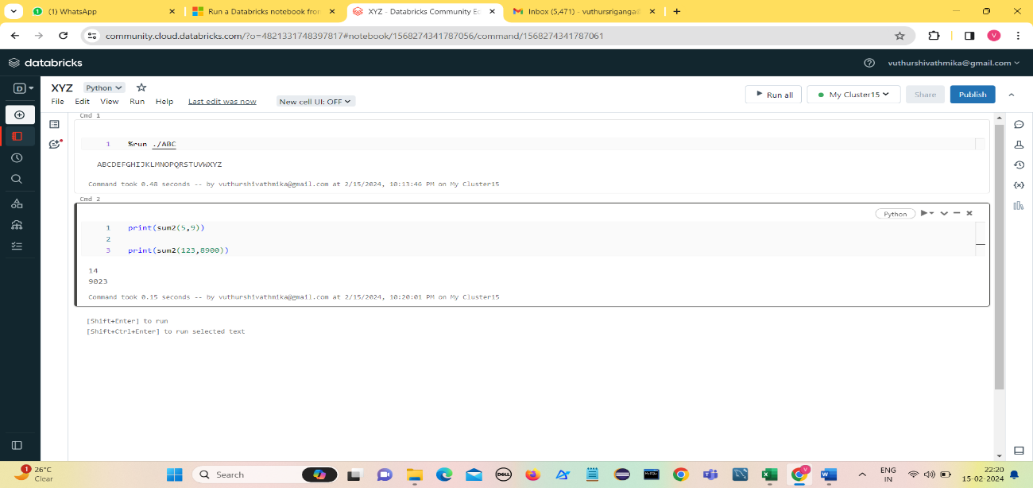**Second notebook**